Infosys Springboard Virtual Internship 6.0 Completion Report
Team Details
Batch Number: 13
Start Date: 02-FEB-2026
S.no | Name
1 | AMMANNAGARI MANOJA
2 | SARVAN KALYANADURG MOHASSIN BASHA
3 | SHANTHA
4 | SHOBANA DEVI A

Internship Duration: 8 Weeks

Project Title
INVENTRA- SMART HOSPITAL PHARMACY SYSTEM
- Project Objective
- Design and develop a smart pharmacy management system to automate hospital pharmacy operations
- Enable real-time tracking of medicines, stock levels, and expiry dates
- Reduce human errors and improve efficiency by replacing manual systems
- Implement role-based authentication for secure system access
- Develop a transaction tracking system for complete audit and traceability
- Provide automated alerts for low stock and expiring medicines
2. Project Description in Detail
The Smart Hospital Pharmacy System is a web-based application developed to modernize and automate pharmacy operations in hospitals. Traditional pharmacy systems rely on manual processes such as maintaining registers and spreadsheets, which often lead to medication errors, inefficient stock management, lack of real-time tracking, and data redundancy. These issues can directly impact patient safety and overall hospital efficiency.
To address these challenges, the system provides a centralized and automated platform that enables administrators and staff to efficiently manage medicines, track inventory, and monitor transactions in real time. The system is designed using a full-stack architecture, ensuring seamless communication between the frontend interface and backend services.
The system consists of several core modules. The Authentication Module provides secure login functionality with role-based access control for Admin and Staff users. It ensures data protection through password encryption and controlled access to system features. The Inventory Management Module allows users to add, update, delete, and monitor medicines, including details such as quantity, expiry date, and price, ensuring accurate stock management.
The Transaction Tracking Module records all stock movements, including stock-in and stock-out operations. Each transaction is stored with detailed information such as date, quantity, and user actions, ensuring transparency and accountability. The Alerts System generates automatic notifications for low stock levels and medicines nearing expiry, helping users take timely action and avoid critical issues.
Additionally, the Reports and Analytics Module provides insights into stock levels, expiry status, and transaction history. These reports help in better decision-making and efficient resource planning.
The system ensures high security through techniques such as password encryption, JWT-based authentication, and role-based access control. It also provides a user-friendly interface, making it easy for hospital staff to operate the system efficiently.
Overall, the Smart Hospital Pharmacy System is a reliable, secure, and scalable solution that reduces manual errors, improves efficiency, and enhances pharmacy management through automation and real-time monitoring.
3. Timeline Overview
Week | Activities Planned | Activities Completed
Week 1 | Requirement analysis, problem identification, and system architecture design | Conducted detailed analysis of existing manual pharmacy systems, identified key issues such as stock mismanagement and lack of automation, gathered system requirements, and designed the overall system architecture including modules and workflow
Week 2 | Database design and backend setup | Designed a normalized MySQL database schema including tables for users, medicines, and transactions; established relationships using foreign keys; set up backend project using Spring Boot and created initial REST API structure
Week 3 | Authentication system and role-based access control | Implemented secure login and registration system; applied password encryption (BCrypt); developed role-based access control for Admin and Staff; added validation and session handling
Week 4 | Inventory management module development | Developed features for adding, updating, deleting, and viewing medicines; implemented search and filter functionality; ensured accurate stock management and real-time updates
Week 5 | Transaction management system | Implemented stock-in and stock-out functionality; developed transaction logging with details such as date, quantity, and user actions; ensured automatic stock updates after each transaction
Week 6 | Alerts system and dashboard development | Developed alert mechanisms for low stock and expiry notifications; created dashboard interface to display real-time alerts and summary of inventory data
Week 7 | System testing, debugging, and optimization | Performed unit testing and integration testing; identified and fixed bugs; optimized database queries and improved system performance and responsiveness
Week 8 | Final system integration, documentation, and deployment | Integrated all modules into a complete system; conducted final testing and validation; prepared project documentation and report; completed project submission

4a. Key Milestones
Milestone | Description | Date Achieved
Project Kickoff | Conducted requirement analysis and planned system architecture and modules | Week 1
Backend Setup | Designed database schema and developed initial backend APIs using Spring Boot | Week 2
Authentication Module | Implemented secure login, registration, and role-based access control | Week 3
Inventory Module | Developed functionality to add, update, delete, and manage medicine stock | Week 4
Transaction System | Implemented stock in/out operations with automatic updates and tracking | Week 5
Dashboard Integration | Created dashboard with alerts, notifications, and data visualization | Week 6
Testing | Performed unit and integration testing, fixed bugs, and optimized performance | Week 7
Final Deployment | Integrated all modules, completed documentation, and finalized the project | Week 8

4b. Project Execution Details
The Smart Hospital Pharmacy System was developed using a full-stack architecture to ensure scalability, security, and efficient performance. The backend was implemented using Java (Spring Boot) to build RESTful APIs that handle business logic, user requests, and communication with the database. MySQL was used as the database to store and manage data related to users, medicines, and transactions.
The frontend was developed using HTML, CSS, Bootstrap, and JavaScript, providing a responsive and user-friendly interface. The frontend interacts with backend APIs to fetch and display real-time data dynamically.
The database was designed using normalized tables to maintain data consistency and reduce redundancy. A secure authentication system with role-based access control (Admin and Staff) was implemented to ensure that only authorized users can access specific features.
The inventory management module allows users to add, update, delete, and monitor medicines with details such as quantity and expiry date. The transaction module records stock-in and stock-out operations and automatically updates inventory levels to maintain accuracy.
Additionally, the system includes an alerts mechanism to notify users about low stock levels and medicines nearing expiry. Testing was conducted at different stages, including unit and integration testing, to ensure system reliability and performance.
5. Snapshots / Screenshots
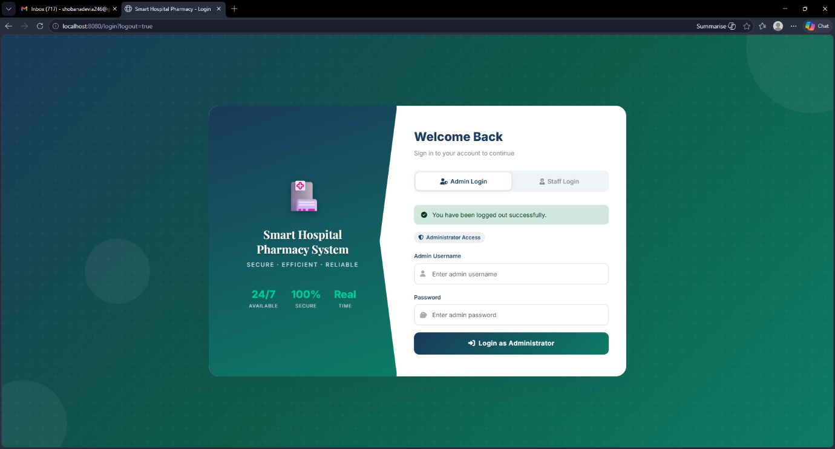

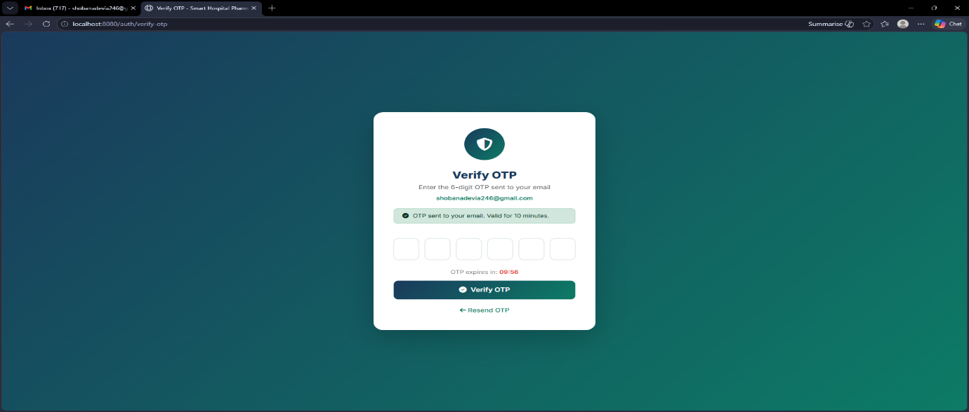

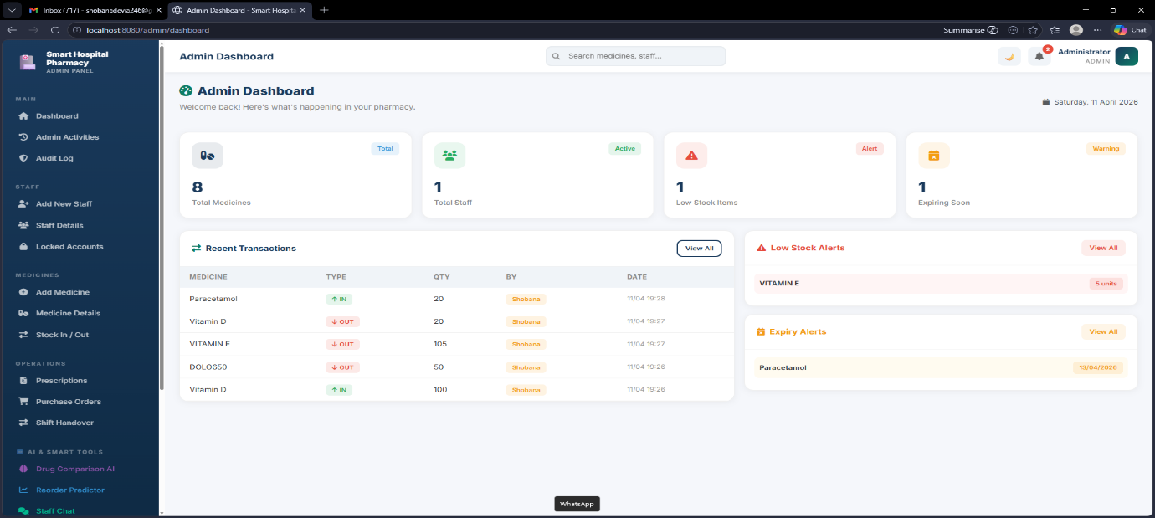

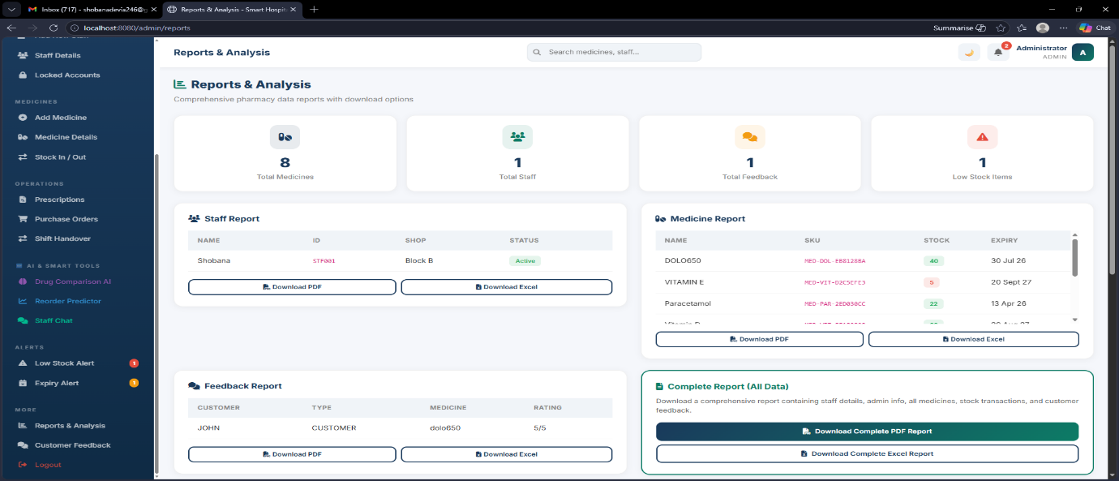

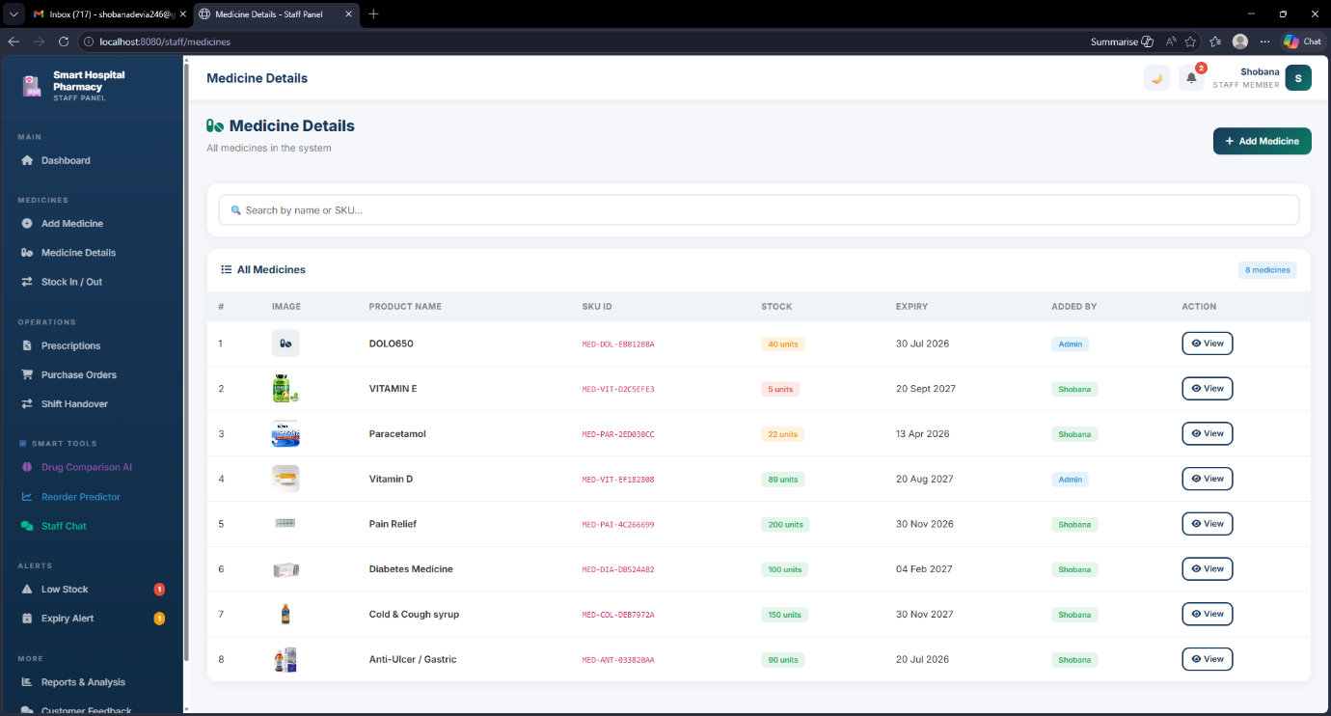

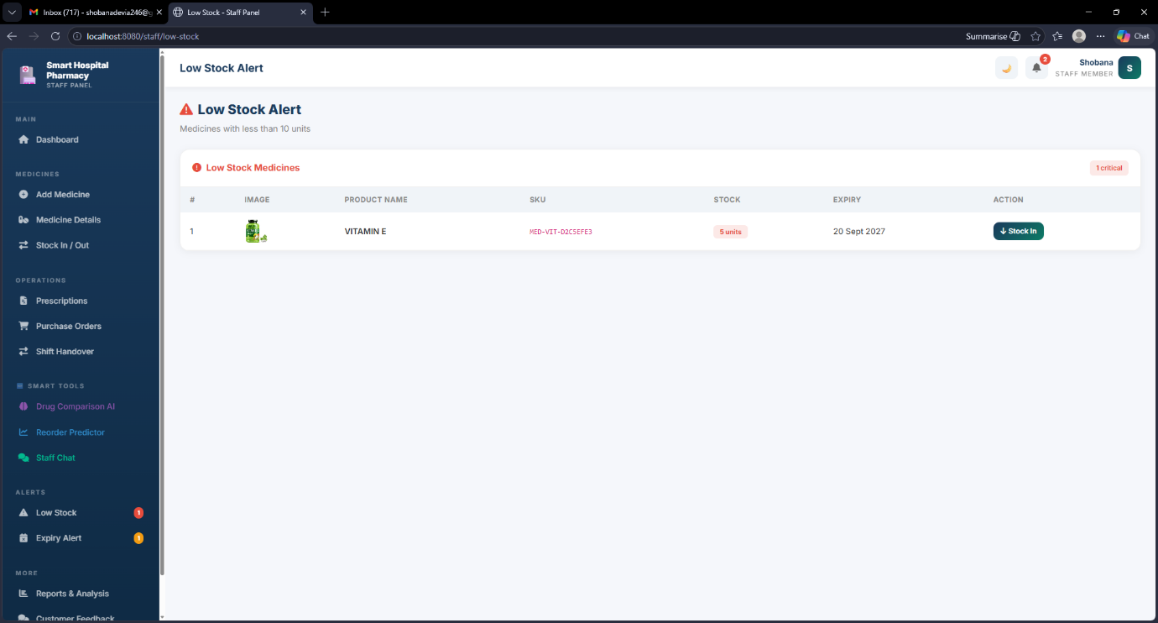

6. Learnings & Skills Acquired
- Gained practical experience in backend development using Java and Spring Boot for building RESTful APIs
- Developed strong understanding of MySQL database design using normalized tables and relationships
- Learned to implement secure authentication and role-based access control for system security
- Acquired skills in frontend development using HTML, CSS, and Bootstrap for responsive UI design
- Understood API integration for smooth communication between frontend and backend systems
- Gained knowledge of real-time inventory management and stock tracking concepts
- Developed overall experience in full-stack application development and module integration

7. Challenges Faced
Challenge 1: Database Design
Problem: Managing relationships between medicines and transactions without data inconsistency
Solution: Designed a normalized database schema with proper foreign keys to maintain data integrity
Challenge 2: Real-Time Updates
Problem: Maintaining accurate stock levels after each transaction
Solution: Implemented automated backend logic to update inventory instantly after stock-in and stock-out operations
Challenge 3: Security Implementation
Problem: Preventing unauthorized access to sensitive system data
Solution: Implemented JWT-based authentication and role-based access control to secure the system
Challenge 4: Frontend-Backend Integration
Problem: Ensuring smooth communication between frontend and backend systems
Solution: Used REST APIs with proper request handling and error management for seamless integration
8. Testimonials from Team
Working on the Smart Hospital Pharmacy System was a valuable learning experience for our team. Each member contributed to different modules such as backend development, frontend design, and database management, which helped us understand how a complete system is built.
The project improved our practical knowledge of technologies like Java, Spring Boot, MySQL, and frontend tools. It also enhanced our problem-solving skills as we worked together to overcome challenges during development.
Additionally, this experience strengthened our teamwork and communication skills. Overall, the project gave us a clear understanding of real-world application development and system integration.
9. Conclusion
The Smart Hospital Pharmacy System effectively converts traditional pharmacy operations into a digital, efficient, and secure system. It reduces manual errors, improves inventory management, and enables real-time tracking of medicines and transactions.
The system includes key features such as secure authentication, automated alerts for low stock and expiry, and detailed reports for better monitoring and decision-making. These features help in improving operational efficiency and ensuring better pharmacy management.
Overall, the project demonstrates strong full-stack development skills and provides a practical solution that can be implemented in real hospital environments.
10. Acknowledgements
We would like to express our sincere gratitude to our faculty and mentors for their continuous guidance, support, and valuable suggestions throughout the development of this project.
We also extend our thanks to our institution for providing the necessary resources and a supportive environment to successfully complete this work. Finally, we appreciate the teamwork, dedication, and collaborative efforts of all team members that contributed to the successful completion of this project.

